Table of Contents
XRLend — XR Headset Borrowing System 1
IFN636 Software Life Cycle Management 1
TASK 1 1
1.1 The Problem 1
1.2 Stakeholders 2
1.3 User Roles 2
1.4 The Two End-to-End Workflows 3
1.5 Scope 4
1.6 Success Criteria 5
1.7 Requirements List 5
1.8 Product Backlog 6
1.9 Sprint Plan 11
1.10 Decision and Change Log 17
1.11 CRUD Coverage 19

XRLend — XR Headset Borrowing System

IFN636 Software Life Cycle Management

Task 1: Problem, Requirements and Project Management

Task 2: System Design

TASK 1

1.1 The Problem
University XR labs hold a small number of expensive headsets that many students need to share. Most labs still run this on a paper sign-out sheet, a whiteboard, or a shared spreadsheet.
This causes four problems:
- Double bookings. Two students book the same headset for overlapping days because nobody can see the full calendar at once.
- No record of who has what. When a headset goes missing, staff cannot say who had it last or when it was due back.
- Students waste trips. A student walks to the lab to find every headset is already out, because availability is not visible before they leave.
- Damage is untracked. A headset comes back with a cracked lens and there is no record linking that damage to a specific loan.
The lab technician ends up doing the scheduling by hand and holding the whole picture in their head.
XRLend fixes this. It is one website where the technician keeps the headset list up to date, students see what is actually free for the dates they want, and every loan is recorded from request through to return.
Why this is worth building. The main problem is a scheduling rule, it's not a data entry form. Two loans of the same headset must not overlap in time. That single rule is what a spreadsheet cannot do and what the system can support.

1.2 Stakeholders
Stakeholder | Type | What they want
Students | Main user | See what is free, book it, and know the booking is confirmed
Lab technician | Main user | Stop double bookings, know where every headset is, less manual scheduling
Lab manager | Secondary | Usage figures to justify buying more headsets
Teaching staff | Secondary | Confidence that students in their unit can get equipment when needed
University IT | Outside | The system follows normal account and security rules
AWS | Supplier | Service stays available

1.3 User Roles
Two roles. The rules are checked on the server, not just hidden in the interface.
Can do | Student | Technician
Sign up and log in | Yes | Yes
Browse the headset list | Yes | Yes
Check availability for a date range | Yes | Yes
Request a loan | Yes | No
Cancel own pending request | Yes | No
See own loan history | Yes | No
Add, edit or retire a headset | No | Yes
Set a headset to under maintenance | No | Yes
Approve or reject a request | No | Yes
Record a collection | No | Yes
Record a return and its condition | No | Yes
See all loans across all students | No | Yes
Sign up as a technician using the staff code | No | Yes

Students can request a headset. Only the technician can approve it and hand it over. This matches how equipment loans normally work, and fewer rules means fewer things to test.

1.4 The Two End-to-End Workflows
Each workflow belongs to a different role and finishes on its own. They meet at the loan request, which is what makes this one system rather than two

Workflow A — Borrow a headset (Student)
Step | What happens | Requirement
A1 | Student logs in | R2
A2 | Browses headsets and enters the dates they want | R4
A3 | System shows which headsets are free for those dates | R5
A4 | Student requests a loan for one of them | R6
A5 | Request sits as Pending until the technician decides | R6
A6 | Student sees the decision on their loan list, with the reason if it was rejected | R7
Finished when: the request has been approved or rejected and the student can see which.

Workflow B — Manage the lab (Technician)
Step | What happens | Requirement
B1 | Technician logs in | R2
B2 | Adds a headset with its model and asset tag | R3
B3 | Headset is saved as Available and students can now find it | R3
B4 | Technician opens the pending request queue | R8
B5 | Checks the dates and approves or rejects, giving a reason if rejected | R9
B6 | Queue updates and the student sees the decision | R9
Finished when: the request has a decision recorded against it and the queue no longer shows it.

1.5 Scope

In scope
- Sign up, log in, log out
- Two roles, chosen at sign up, with a staff code required for the technician role.
- Headset records with model, asset tag, status and notes
- Availability search across a date range
- Loan requests with start and end dates
- Approve and reject steps, with a reason on rejection
- Recording collection and return, built after the two workflows
- Overlap checking so one headset cannot be double booked
- Student loan history
- Technician view of all loans
- Input checks on all forms
- Manual deployment to AWS EC2 with written steps

Out of scope
Left out | Why
Payments, fines or deposits | Brings in payment security rules, too big for this unit
Email or SMS alerts | Needs an external mail service and adds a dependency we do not need to show the workflow
University single sign-on | Normal login is enough and keeps the system self-contained
Barcode or QR scanning | Needs hardware we do not have. The asset tag is typed in
Mobile apps | A responsive website is enough
Booking rooms or desks as well | Headsets only. Adding more equipment types would widen the model without adding new reasoning
Waiting lists | If nothing is free the student picks other dates. A queue adds a lot of rules for little value here
Usage reports and charts | Counting loans is enough. Charts do not test any new rule
Automatic CI/CD | The brief says this is out of scope

Assumptions
- One AWS region (ap-southeast-2) and one EC2 instance, same as Tutorial 4.
- Data is stored in MongoDB Atlas, same as Tutorial 4.
- The lab holds 30 headsets, so availability can be checked without heavy optimisation.
- Loans are whole days. There are no hourly bookings.
- Collection and return happen in person, so the system records them but does not control them.
- One technician is on duty at a time, so two staff will not approve the same request at once.
- The team is 1 person working about 15 hours a week.
- The site only needs to be running during the marking period.
- AWS free tier is enough for a demo with a few users.
- The lab holds a single staff access code, given out in person by the lab manager. There is no per-person staff invite.

1.6 Success Criteria
Each one can be checked. Vague goals like “easy to use” are not included because you cannot measure them.
ID | Criteria | How to check | Target
SC1 | No headset has two approved loans that overlap in time | Query the database for overlapping approved loans | 0
SC2 | A student can go from login to a submitted request | Time a walkthrough | Under 3 min
SC3 | Availability results match the loan records | Book 5 test loans, compare search results against the database | 100% match
SC4 | Tests pass on the release tag | Run the test suite | All pass
SC5 | API is fast enough | Time 20 availability searches, check the 95th percentile | Under 400 ms
SC6 | Controller test coverage | Coverage report | 70% or more
SC7 | Roles are enforced on the server | Try 6 requests with the wrong role token | 0 get through
SC8 | No passwords or keys in the repo | Search the git history | 0 found
SC9 | Site is reachable during marking | Load the public URL | 200 OK
SC10 | Every requirement traced to a commit | Check the traceability matrix 2.2 | All of R1–R16

1.7 Requirements List
Sixteen requirements. Twelve say what the system does. Four say how it has to behave. R1 to R8 are the accounts tree. Each step in it is built and tested on its own, so each one is its own requirement.
These IDs are used in the backlog, the diagrams and the traceability matrix. They do not change again.

Functional
ID | Name | Requirement
R1 | Sign up | A visitor can create an account and pick a role
R2 | Staff code check | Check the staff code before a technician account is made
R3 | Roles | The system has two roles, Student and Technician. Every account has exactly one
R4 | User authentication | Secure authentication with a hashed password and a session token
R5 | Log in | Start a session and open the dashboard for the role
R6 | Log out | End the session and clear the token
R7 | Password check | Compare the password against the stored hash
R8 | Session end | Clear the token so protected pages return to login
R9 | Manage headsets | A technician can add, edit, set the status of, and retire a headset
R10 | Browse and search | A student can browse headsets and search availability for a date range
R11 | Request and track loans | A student can request a loan, see their own loans, and cancel a pending request
R12 | Decide and record | A technician can see pending requests, approve or reject with a reason, and record collection and return

Non-functional
ID | Name | Requirement | Backed by
R13 | No overlapping loans | Two approved loans for the same headset must never overlap in time | SC1
R14 | Security | Roles are checked on the server and passwords are stored as hashes | SC7
R15 | Performance | The availability search answers in under 400 ms with 30 headsets | SC5
R16 | Usability | A student can go from login to a submitted request in under 3 minutes | SC2

R13 is the rule the system exists for. R10 and R12 come from it, because searching and approving are the only two places it is enforced. R7 comes from R14. R14 comes from R3, because there is no point checking a role on the server unless there is more than one role.

1.8 Product Backlog
Four epics, 16 stories, 85 points. 80 points are Must and 5 are Should. Priority uses MoSCoW. Estimates use 1, 2, 3, 5 and 8.
Epic | Name | Pts | Needs first
1 | Foundations | 30 | Nothing
2 | Headset Inventory | 13 | Epic 1
3 | Availability and Requests | 24 | Epic 2
4 | Approvals and Returns | 18 | Epic 3
 | Total | 85

Epic 1 — Foundations · 30 points
Accounts, roles, the database, the server and the tests. A user never sees any of it, but nothing else works without it.
Story 1.1 — Sign up · 5 pts · Must · R1, R2, R3, R4, R7
As a visitor, I want to make an account, so that I can use the system.
Acceptance criteria
- Given valid details and the Student role, when I submit, then my account is created with the student role.
- Given the Technician role and the right staff code, when I submit, then my account is created with the technician role.
- Given the Technician role and a wrong or blank staff code, when I submit, then I see an error and no account is made.
- Given a new account, when I look in the database, then the password is stored as a hash.
- Given any account, when I look at it, then it has exactly one role.
Sub-tasks
- Sign up form, role picker, staff code check against an environment variable, password hashing, user model.
Story 1.2 — Log in and log out · 5 pts · Must · R5, R6, R8
As a user, I want to log in and out, so that only I can reach my own pages.
Acceptance criteria
- Given the right details for a student, when I log in, then I reach the student dashboard.
- Given the right details for a technician, when I log in, then I reach the technician dashboard.
- Given wrong details, when I log in, then I see one message that does not say which field was wrong.
- Given I am logged in, when I log out, then my token is cleared and protected pages send me back to login.
Story 1.3 — Role check middleware · 5 pts · Must · R14
As a technician, I want role checks on the server, so that a student cannot reach my pages by changing the URL.
Acceptance criteria
- Given a student token, when it is sent to a technician route, then the server returns 403.
- Given no token, when a protected route is called, then the server returns 401.
- Given a technician token, when it is sent to a technician route, then the request goes through.
Story 1.4 — Set up the database and EC2 · 5 pts · Must · Task
Acceptance criteria
- MongoDB Atlas is connected and the EC2 public IP is on the access list.
- The EC2 instance runs the app and the public URL loads.
- Inbound rules only open the ports the app needs.
Story 1.5 — Write the README and deployment steps · 5 pts · Must · Task
Acceptance criteria
- The README has setup, a short architecture summary, known limits and the deployment URL.
- The deployment steps are good enough to rebuild the server from scratch.
- No password, key or connection string is anywhere in the repo, and `.env` is in `.gitignore`.
Story 1.6 — Unit tests to 70% coverage · 5 pts · Must · Task
Acceptance criteria
- Controller coverage is 70% or more.
- The seven overlap cases from Story 3.2 all pass.
- The wrong-role test from Story 1.3 passes.

Epic 2 — Headset Inventory · 13 points · Needs Epic 1
The technician side of Workflow B. Headsets have to exist before anyone can borrow one.
Story 2.1 — Add a headset · 5 pts · Must · R9
As a technician, I want to add a headset, so that students can see it and book it.
Acceptance criteria
- Given a model and an asset tag, when I save, then the headset shows in the list as Available.
- Given an asset tag that already exists, when I save, then I see an error and nothing is created.
- Given I am a student, when I call the add route, then the server returns 403.
Sub-tasks
- Headset model, POST route, add form, unique asset tag check.
Story 2.2 — Edit a headset and set its status · 5 pts · Must · R9
As a technician, I want to change a headset record, so that the list stays right.
Acceptance criteria
- Given I change the model or the notes, when I save, then the list shows the new values.
- Given I set a headset to Maintenance, when a student searches, then it does not show up.
- Given a headset has approved future loans, when I set it to Maintenance, then I am warned before it saves.
Story 2.3 — Retire a headset · 3 pts · Must · R9
As a technician, I want to retire a broken headset, so that nobody can book it.
Acceptance criteria
- Given I retire a headset, when a student searches, then it never shows up.
- Given a retired headset, when I open an old loan, then the headset still shows on that record.

Epic 3 — Availability and Requests · 24 points · Needs Epic 2
All of Workflow A. This is where the overlap rule is enforced for the first time.
Story 3.1 — Browse the headset list · 3 pts · Must · R10
As a student, I want to see what headsets exist, so that I know what I can ask for.
Acceptance criteria
- Given I am logged in as a student, when I open the list, then I see model, asset tag and status.
- Given there are no headsets, when I open the list, then I see a message, not a blank page.
Story 3.2 — Search availability for a date range · 8 pts · Must · R10, R13, R15
As a student, I want to enter my dates and see only what is free, so that I do not ask for something already booked.
Acceptance criteria
- Given a start and an end date, when I search, then only headsets with no Pending or Approved loan across those dates show up.
- Given an end date before the start date, when I search, then I see a message and nothing is sent.
- Given nothing is free, when I search, then I see a message suggesting other dates.
- Given 30 headsets in the database, when I search, then the answer comes back in under 400 ms.
Sub-tasks
- Overlap query, availability route, date picker, seven boundary tests.
The seven overlap tests
An existing loan runs day 10 to day 14. A new request must be refused for 8 to 12, 12 to 14, 14 to 18, 8 to 18 and 10 to 15. It must be allowed for 5 to 9 and for 16 to 20.
Story 3.3 — Request a loan · 8 pts · Must · R11, R13, R16
As a student, I want to request a headset for my dates, so that a technician can decide.
Acceptance criteria
- Given a free headset and valid dates, when I submit, then a loan is created with the status Pending.
- Given someone booked the same dates while I was filling in the form, when I submit, then my request is refused with a message saying it is no longer free.
- Given I am a technician, when I call the request route, then the server returns 403.
- Given a new student account, when the path from login to a submitted request is timed, then it takes under 3 minutes.
Sub-tasks
- Loan model, POST route, second overlap check before save, request form.
Story 3.4 — See my loans and cancel a pending request · 5 pts · Must · R11
As a student, I want to see my requests and drop one I no longer need, so that I know where I stand and do not hold dates I will not use.
Acceptance criteria
- Given I have loans, when I open my loans, then I see each one with its dates and status, newest first.
- Given a request was rejected, when I open my loans, then I can see the reason.
- Given a Pending request, when I cancel it, then the status becomes Cancelled and those dates are free again straight away.
- Given an Approved loan, when I open it, then there is no cancel button.

Epic 4 — Approvals and Returns · 18 points · Needs Epic 3
The rest of Workflow B. The decision is where the overlap rule is checked for the last time.
Story 4.1 — See the pending request queue · 5 pts · Must · R12
As a technician, I want one list of everything waiting, so that nothing sits unanswered.
Acceptance criteria
- Given there are pending requests, when I open the queue, then I see student, headset and dates, oldest first.
- Given the queue is empty, when I open it, then I see a message, not a blank page.
- Given I am a student, when I call the queue route, then the server returns 403.
Story 4.2 — Approve or reject a request · 8 pts · Must · R12, R13
As a technician, I want to decide on a request, so that the student knows where they stand.
Acceptance criteria
- Given a pending request with no clash, when I approve it, then the status becomes Approved and the student can see it.
- Given a clash appeared since the request was made, when I approve it, then it is refused and the status stays Pending.
- Given I reject a request, when I save, then a reason is required and the student can see it.
Sub-tasks
- Approve route, reject route with reason, second overlap check inside approve, clash test.
Story 4.3 — Record collection and return · 5 pts · Should · R12
As a technician, I want to record the handover and the return, so that the lab knows who has what.
Acceptance criteria
- Given an approved loan, when I record collection, then the status becomes Collected with a timestamp.
- Given a collected loan, when I record the return, then the status becomes Returned and I can mark the condition as Good or Damaged.
- Given a returned loan, when a student searches those dates, then the headset is free again.

1.9 Sprint Plan
Two sprints, three weeks each. Once a sprint starts, nothing is added to it. Both sprints hold Must work only. The one Should story is left for a third sprint.
Sprint length | 3 weeks. At `15` hours a week, a two-week sprint cannot hold a whole workflow, so there would be nothing to show at the first review.
Team | `1` person. The jobs below are all done by the same person.
Capacity | 45 hours a sprint.
Velocity | Sprint 1 was planned at about one hour a point. Sprint 2 uses the real Sprint 1 number.
Board | Jira. To Do, Blocked, Blockers, In Progress, In Review, Testing, Done.

Who owns what
One person does all the work, so ownership is shown as the job being done. The reviewer job is what catches the mistakes the developer job made.
Job | What it covers | Who
Developer | Writes the code and the tests. Makes the branch and pushes the commits. | Ali rezaeimanesh
Reviewer | Opens the pull request, writes the self-review comment, checks no secrets were committed, merges. | Ali rezaeimanesh
Product owner | Sets the priority and accepts stories against their acceptance criteria. | Ali rezaeimanesh

Definition of Done
A story is only Done when all five are true. Points are not counted before that.
- Every acceptance criterion has been run by hand and passes.
- New server rules have unit tests and those tests pass.
- The branch is merged into main through a pull request with a self-review comment.
- No password, key or connection string is in the commit.
- The change is on EC2 and works on the public URL.

Sprint 1: Accounts and inventory
Dates | `dd/mm` to `dd/mm`
Goal | A technician can log in and add headsets. A student can log in and see them. Workflow B steps B1 to B3 work on the live URL.
Committed | 41 points

ID | Item | Pts | Needs first
1.4 | Set up the database and EC2 | 5 | Nothing
1.1 | Sign up | 5 | 1.4
1.2 | Log in and log out | 5 | 1.1
1.3 | Role check middleware | 5 | 1.2
1.5 | Write the README and deployment steps | 5 | 1.4
2.1 | Add a headset | 5 | 1.3
2.2 | Edit a headset and set its status | 5 | 2.1
2.3 | Retire a headset | 3 | 2.1
3.1 | Browse the headset list | 3 | 2.1
 | Total | 41

1.3 is built before the inventory work even though users never see it. Every story in Epic 2 has a criterion that says a student gets a 403, and there is nothing to test that against until the middleware exists.
Blockers
Item | Waiting on | Why it was stuck | How it cleared
1.1 Sign up | 1.4 Database | No account can be saved without a database. | Atlas connected on day 2.
2.1 Add a headset | 1.3 Role middleware | The 403 criterion could not be tested. | 1.3 done on day 8. Came out of Blocked the same day.
1.4 Database | Outside the team | The EC2 public IP was not on the Atlas access list. The app worked on the laptop but not on the server. | IP added to the Atlas list. Half a day lost.
Risks
ID | Risk | Chance | Impact | What we do about it
RK1 | The free tier EC2 instance runs out of disk during npm install. | Medium | High | Grow the disk before deploying, using the Tutorial 1 steps.
RK2 | Atlas blocks the EC2 instance because its IP is not on the access list. | Medium | Medium | Add the IP on day 1.
RK3 | Role checks end up in the interface only and not on the server. | Low | High | 1.3 has its own test that sends a student token to a technician route.
RK4 | A secret gets committed early and stays in the git history. | Low | High | Check the repo in Sprint 1, not at the end.
Review
Committed | 41 points
Done | 41 points
Real velocity | 41 points
Goal met | Yes. Both roles log in, headsets can be added and edited, and students see the list on the live URL.

Sprint 2: Availability, requests and approvals
Dates | `dd/mm` to `dd/mm`
Goal | Workflow A and Workflow B both work end to end. A student can search, request and see the answer. A technician can see the queue and decide.
Committed | 39 points

ID | Item | Pts | Needs first
3.2 | Search availability for a date range | 8 | 2.1, 3.1
3.3 | Request a loan | 8 | 3.2
3.4 | See my loans and cancel a request | 5 | 3.3
4.1 | See the pending request queue | 5 | 3.3, 1.3
4.2 | Approve or reject a request | 8 | 4.1, 3.2
1.6 | Unit tests to 70% coverage | 5 | All of the above
 | Total | 39

3.2 goes first because the rest of the sprint leans on it. The overlap query it builds is used again by 3.3 and again by 4.2.
Blockers
Item | Waiting on | Why it was stuck | How it cleared
3.3 Request a loan | 3.2 Search availability | The request runs the same overlap check the search runs. Writing it twice would let the two drift apart. | 3.2 done on day 5. The query went into one function and both call it.
4.1 and 4.2 | 3.3 Request a loan | Nothing to queue and nothing to approve until requests exist. | 3.3 done on day 8.
4.2 Approve or reject | An open question | Blocked for 2 days. It was not clear what should happen if a clash appears after the request was made. | Settled by decision D5. The approve step checks a second time and refuses if it clashes.
Risks
ID | Risk | Chance | Impact | What we do about it
RK5 | Two approvals both pass the overlap check before either one saves, and the headset gets double booked. | Medium | High | The approve step checks the database again and refuses if it clashes. See D5.
RK6 | Time zones move a loan by a day, so a search and a loan record disagree. | Medium | Medium | Dates are stored as UTC midnight and compared as whole days.
RK7 | The 70% coverage target is missed because tests are left to the last week. | Medium | Medium | Tests are written with each story. 1.6 only fills the gaps.
RK8 | The EC2 instance is down or the URL changed during marking. | Low | High | Load the public URL once a day through the marking week.
Review
Committed | 39 points
Done | 39 points
Real velocity | 39 points
Coverage | 72% on the controllers, against a 70% target
Goal met | Yes. Both workflows work end to end on the live URL and the seven overlap tests pass.

5 points are left after Sprint 2. That is Story 4.3, recording collection and return. Both handovers happen at the counter in person, so neither workflow needs it. A third sprint would pick it up first.

1.10 Decision and Change Log
Rows are added, never edited. If a decision is undone later, the reversal gets its own row.
ID | What changed | Why | Evidence looked at | Affected
D1 | The project changed from a game playtesting platform to an XR headset borrowing system. | The borrowing system has a real scheduling rule in the middle of it. Two loans of the same headset cannot overlap, and a spreadsheet cannot do that. | The approved project list, item 61. Confirmed by the tutor by email. | All of Task 1, the backlog, every diagram
D2 | Two roles only, Student and Technician. A Lab Manager role was dropped. | A manager role would only read data. It adds screens but no new rule to test. | The permission table in 1.3. Lab manager stays a stakeholder but is not a user role. | 1.2, 1.3, R3, Epic 1
D3 | Workflow A was picked for the behaviour view, drawn as an activity diagram rather than a sequence diagram. | Workflow A has the availability check in it, so it shows more of how the system works. Workflow B is mostly a status change. Activity was chosen over sequence because the only behavioural example in the unit material is an activity diagram, so the notation can be matched to something taught. | R13 and the seven overlap tests in Story 3.2. The activity diagram on Week 1 slide 70. | Task 2, the traceability matrix
D4 | Delete became a status change instead of removing the record. | Loan history has to survive. Deleting a headset would leave old loans pointing at nothing. | The criterion on Story 2.3 that says old loans still show the retired headset. | Stories 2.3 and 3.4, the block definition diagram
D5 | A second overlap check was added inside the approve step. | A clash can appear in the gap between a student searching and a technician approving. One check is not enough to keep R13 true. | Walking through Workflow A step by step showed the gap. | Story 4.2, R13, SC1, the activity diagram
D6 | Sprints are 3 weeks, not 2. | At `15` hours a week a two-week sprint cannot hold a whole workflow. | 80 Must points against 45 hours a sprint. The tutor confirmed at least two iterations are expected. | 1.9
D7 | Sign up offers both roles, and picking Technician asks for a staff code checked against an environment variable. | The scope said the role is picked at sign up, but sign up only ever made students, so no technician account could exist. A plain dropdown was rejected because anyone could make themselves a technician. | R14 and the wrong-role tests in Story 1.3. A marker also has to be able to make a technician account during marking. | 1.3, 1.5, R2, Story 1.1, the requirement diagram
D8 | Epics went from 5 to 4 and the backlog was merged. | Deployment, docs and testing had no user story attached, so they moved into Foundations with accounts and roles. Stories that share a screen or a form were merged. | The tutor confirmed there is no recommended number of epics. | 1.8, 1.9, 2.2
D9 | The accounts tree was split into eight requirements. Roles became a requirement of its own. The non-functional group grew from two to four. | Signing up, authenticating, logging in and logging out are built and tested separately, so one requirement covering all of them could not be verified as one thing. Student and Technician were used all through the document but never written down, so nothing said there are exactly two or that an account has one. The old security requirement held three rules in one box. | Tutor feedback asking whether the relationships are correct and sensible. The role table in 1.3 and criteria SC1, SC2, SC5 and SC7 already set the four non-functional targets. | 1.6, 1.7, 1.8, 1.9, 2.1, 2.2, the requirement diagram

TASK 2 — SYSTEM DESIGN

2.1 The Diagrams
Three diagrams. They are all in one draw.io file, one per tab, and the link is on the cover page. The requirement diagram shows what the system must do. The block definition diagram shows what the system is made of. The activity diagram shows how a student borrows a headset from start to finish. No two of them show the same thing.

2.1.1 Requirement Diagram
Sixteen requirements in two groups under one root, joined by containment. The Functional box holds the three starting points: R1 Sign up, R3 Roles and R9 Manage headsets. Everything else hangs off those.
Sign up requires Roles, because an account cannot be made without a role to give it. The staff code check is required before a technician account exists. R4 depends on R1, R5 and R6 both depend on R4, and R7 and R8 sit underneath as the parts log in and log out need.
On the other branch, R10 depends on R9 because you cannot search headsets that do not exist. R11 depends on R10 and R12 depends on R11. That chain is also the order the sprints build them in.
Four derive links cross to the non-functional side. R10 and R12 come from R13, because searching and approving are the only two places the overlap rule is enforced. R7 comes from R14. R14 comes from R3.
The two actors sit outside the frame and both point at R3 with a refine link. R3 says two roles exist. The actors are what those roles are, so R3 is the only sensible thing for them to point at.
Three test cases say how the non-functional requirements are proved. R16 has none, because it is measured by timing a person through the prototype rather than by a unit test.

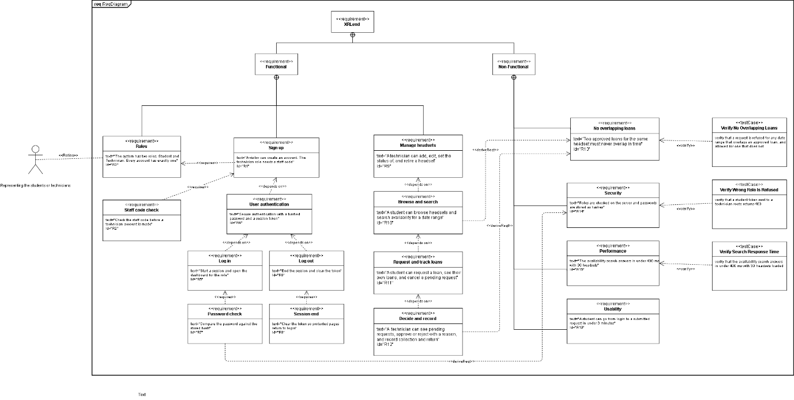2.1.2 Block Definition Diagram
This is the system design diagram. The XRLend System block is made of a Web Client, an API Server and a Database. The API Server opens up into RoleMiddleware and three controllers. The Database opens up into User, Headset and Loan, each with its values and operations.
Four enumerations fix the values that matter. RoleType holds the two roles from R3. LoanStatus is the important one, with six values a loan can be in.
A constraint block called NoOverlap is attached to Loan. It holds R13 as an expression: a new loan is only allowed if it finishes before the existing one starts, or starts after it finishes. That block is what makes this a SysML diagram rather than a plain class diagram.

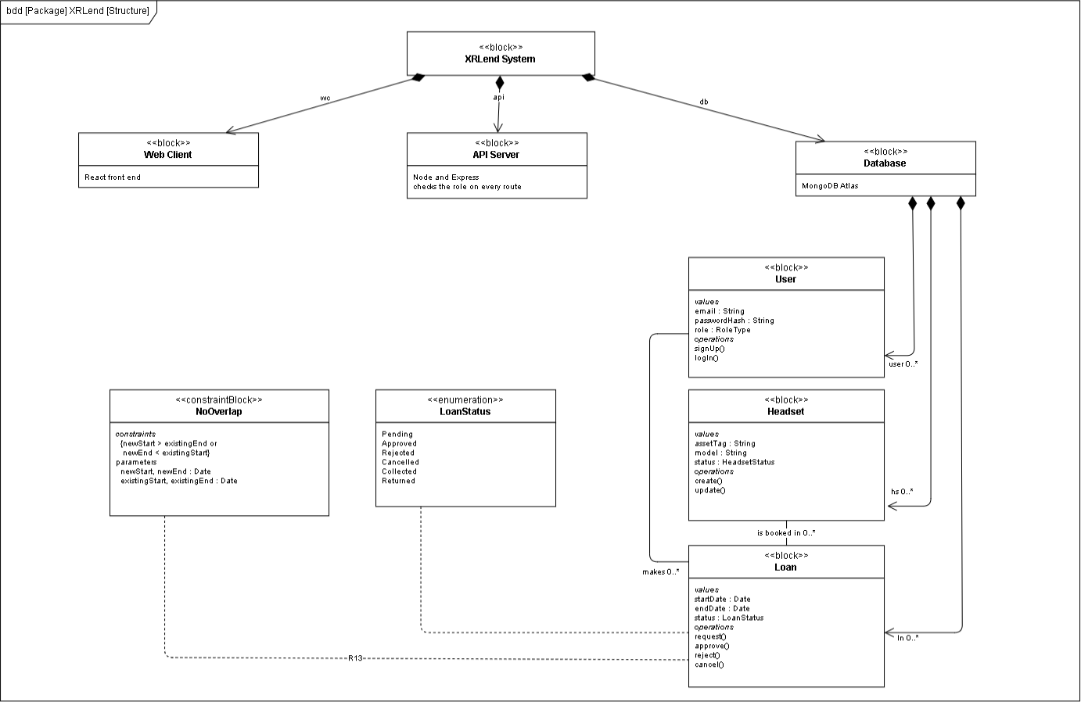2.1.3 Activity Diagram — Workflow A
Workflow A was picked over Workflow B in decision D3. The diagram has three swimlanes, one per block: Student, XRLend System and Lab Technician. XRLend System is marked as the system of interest, the same way the activity diagram in the Week 1 lecture marks the ESS block.
It starts when the student enters their dates and ends when they see the decision. Three decision nodes carry the branches. Is anything free, which loops back to the dates if not. Was a clash found, which refuses the request and stops. And approve or reject, which sets the status either way.
The first two decision nodes are the same rule checked at two different moments. A clash can appear while the student is filling in the form, so checking once at search time is not enough. That is decision D5, and the two diamonds are what make it visible.

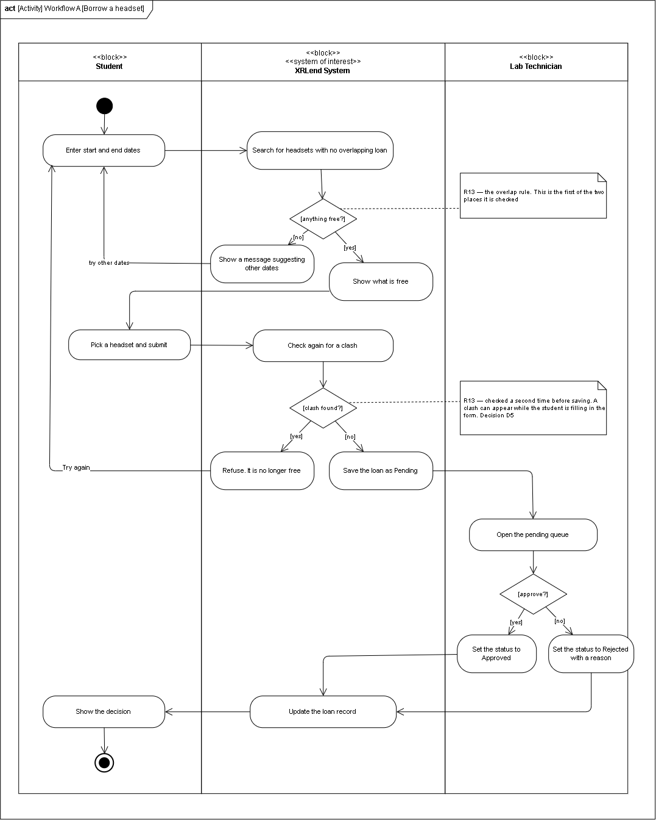2.2 Traceability Matrix
Every requirement is followed from the backlog, through the design, into the interface, and out to a commit and the running site.
Req | Story | Design element | Figma frame | Commit | Deployment evidence
R1 | 1.1 | User block, signUp() | 01 Sign up | `sha` | New account created on the live site
R2 | 1.1 | AuthController, staff code check | 01 Sign up | `sha` | Wrong staff code makes no technician account
R3 | 1.1, 1.3 | RoleType enumeration, User.role | 01 Sign up role picker | `sha` | Every account row carries one role
R4 | 1.1 | User.passwordHash, token issue | 01 Sign up, 02 Log in | `sha` | Token is returned and accepted by protected routes
R5 | 1.2 | User.logIn(), AuthController | 02 Log in, 03 Log in error | `sha` | Both dashboards reachable after login
R6 | 1.2 | AuthController, token clear | Account tab | `sha` | Protected pages return to login after logout
R7 | 1.1 | Compare password action, Student lane entry | Not a screen. Server side only | `sha` | Database shows a hash, never plain text
R8 | 1.2 | RoleMiddleware, token check | Not a screen. Server side only | `sha` | An old token is refused after logout
R9 | 2.1, 2.2, 2.3 | Headset block, create() update() retire() | 12 Headsets | `sha` | Headset added live and visible in the list
R10 | 3.1, 3.2 | HeadsetController, Headset.isAvailable() | 05 Find a headset, 07 empty | `sha` | Search returns only free headsets
R11 | 3.3, 3.4 | Loan block, request(), cancel() | 08 Request, 09 Sent, 10 My loans | `sha` | Request saved as Pending, cancel frees the dates
R12 | 4.1, 4.2, 4.3 | LoanController, Loan.approve(), Loan.reject() | 13 Requests waiting, 14 Reject | `sha` | Status changes and the student can see it
R13 | 3.2, 3.3, 4.2 | NoOverlap constraint block, both overlap decision nodes | 05 Find a headset | `sha` | The overlap test suite passes on the release tag
R14 | 1.1, 1.3 | RoleMiddleware block, the XRLend System lane | Not a screen. Server side only | `sha` | A wrong-role token returns 403 on the live API
R15 | 3.2 | Headset.isAvailable(), the availability index | 05 Find a headset | `sha` | Search answers in under 400 ms with 30 headsets
R16 | 3.2, 3.3 | The Student lane, start node to Show the decision | 02 Log in through to 09 Request sent | `sha` | Timed walkthrough of the deployed site

Fill in the commit column with the short SHA of the commit that finished each story. R12 stays partly empty until Story 4.3 is built in a third sprint, which is explained in 1.9.

